

University of St.Gallen

School of Management, Economics, Law, Social Sciences and International Affairs

Data Analytics II: PC2

University of St. Gallen

Jonas Husmann | 16-610-917

Niklas Leander Kampe | 16-611-618

Prof. Dr. Michael Lechner

March 07, 2022

**Part 1: Data Preparation**

1. Load Data Set

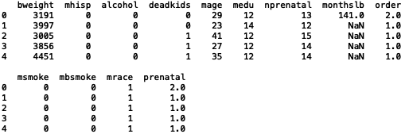

1. Summary Statistics and Histograms + Anomalies or Missing Values

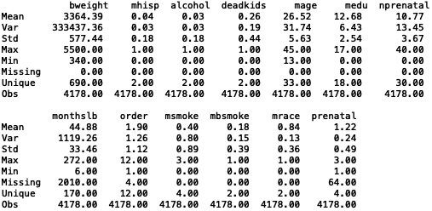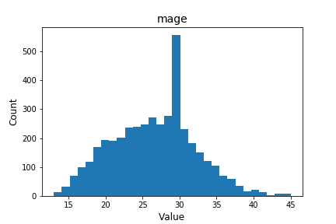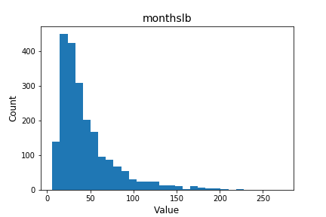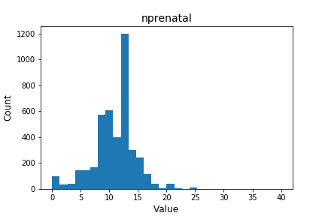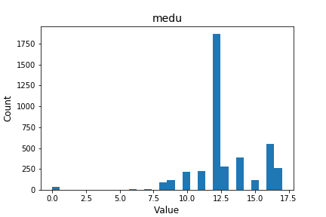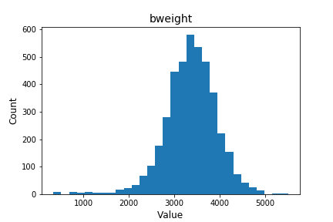

From the summary statistics above, it’s observable that all dummy variables are coded correctly, which can be seen from the min-value of 0, max-value of 1 and the number of unique values of 2. Furthermore, the other variables “bweights”, “mage”, “medu”, “nprenatal”, “monthslb”, “order”, “msmoke” and “prenatal” seem also to have no anomalies since the min-, max- and number of unique values match the variable definition and their description (e.g., variables coded on a 3-step interval have indeed 3 unique values or reasonable birth weights).

1. Variable and Row Drops

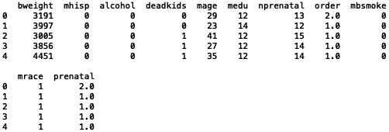

﻿Lorem Ipsum

1. Dummy Variable Recoding

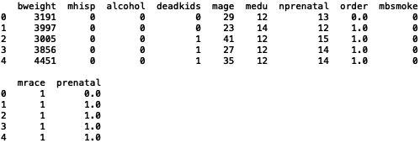

Lorem Ipsum

1. Summary Statistics + Suitability for Economic Analysis

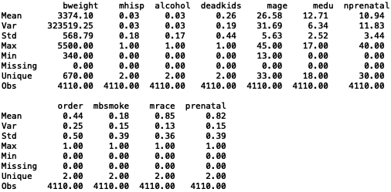

Lorem Ipsum

1. Balancing Checks

Ein Bild, das Tisch enthält.

Lorem Ipsum



Lorem Ipsum

**Part 2: ATE Estimation**

1. OLS Function for ATE Estimation without Covariates
2. OLS Function for ATE Estimation with Covariates